Jane Pottenger

The following information obtained from Geni.com

Birthdate: | June 10, 1618
Birthplace: | Lambourne, Berkshire, England
Death: | after 1655  Calvert County, Maryland

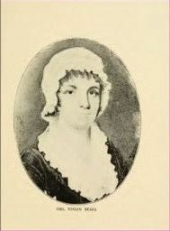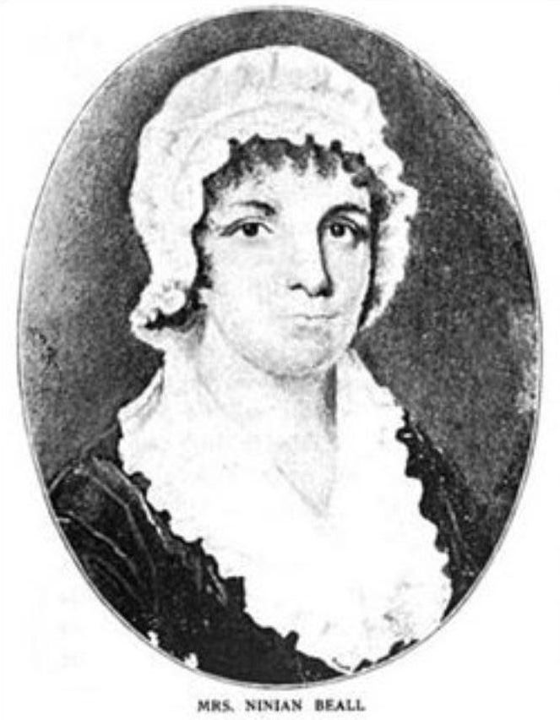

From http://www.myarnolds.com/individual.php?pid=I6054&ged=MYERS.ged
- Father: Richard Potynger (OGFN: 62468972) Birth: 1570 at Burfylde, Berks, England, Great Death:
- Mother: Margaret Butts (OGFN: 62468973 Birth: 1575 at Burfylde, Berks, England, Great Britian
- Marriage 1 Richard MOORE b: 1622 in St. Marys,MarylandMarried: 1640 in England
Children
- Ruth (Polly) MOORE b: 1648 in St. Marys or Calvert,Md.
- Ann MOOR b: 1640 in England
- Mary MOOR b: 1642 in England
- Richard MOOR b: 1646 in England
- Roger MOOR b: 1648 in England
- Temperance MOOR b: 1650 in England

Disputed Identity
From https://www.wikitree.com/wiki/Moore-3693#_note-neck
1634 Marriage to Jane
All we know is that Richard Moore wife was named Jane, and that their marriage took place before Richard and Jane immigrated to Maryland in 1652. As noted in the estimation of dates for their children, below, their oldest child, Temperance, was likely born about 1635. This would place their marriage date at about 1634.
Some genealogies show him as the husband of Jane Hollingsworth, b. 1628. However, the parents assigned to this Jane do not have a daughter named Jane, there is no evidence such a person existed, and if there were such a person, it is not clear whether she would be married to Richard Moore of Maryland or Richard More of Massachusetts, both of whom had wives named Jane. In addition, genealogies showing a Jane Hollingsworth are most often associated with a presumed daughter Ruth Moore, who herself may be a doubtful person, said to have married Ninian Beall.
Some genealogies show him as the husband of Jane Pottenger who was born in England and died in Virginia. Jane was born 1738, 100 years after Richard. He had died before she was born and they could not possibly have been husband and wife. She has been detached as a wife of Richard Moore

Sources
- Page 147 of Ancestors of Jimmy and Rosalynn Carter By Jeff Carter
- link to Archives of Maryland, Volume 10 edited by William Hand Browne, Clayton Colman Hall, Bernard Christian Steiner

Notes
From http://www.myarnolds.com/individual.php?pid=I6054&ged=MYERS.ged
The following concerning Jane, the wife of Richard moore and mother ofRuth Beall, is interesting:
"Know all men by these presents that Whereas my Husband, Richard Moore,being Sick and weake upon his death bed did Call to his wife Jane Moore,and desired her to bring him the will which he had formerly made and hepused it and after that he Cancelled it and caused it to be burnt andmade his wife whole and Sole Executor to Sett and dispose of amongst herchildren, as She will, Richard Manship and Eliz. Manship, his wife, beingpresent at the Same Time." "Know all men by these presents that I, JaneMoore, the wife of Richard Moore deceased, doe bind over the four hundredAcres of land which we now live upon to be Equally Divided betwixt mythree sons, viz.: Richard M., Roger M., and Timothy M., and they to be ofage when they come to Eighteen, and the Maids at fifteen, and fourteenhead of female Cattell for Seven Children for their use with all theIncrease, the Males being taken out of them and as the Come to age ormarry their shares to be taken out proportionately, and if any of theseChildren should Dye the Cattell to goe aomngst the rest, and for the LandShe is to Enjoy ir, So Long as She, the Said Jane, doth Live and then toCome to the Children." July 1654. (X) The marke of Jane O. Moore. Maryland Archives, Volume 10, Page 393
- ***************************************
"Know all by men presents that Whereas, I, Peter Godson, Chirugeon,intending to intermarry with Jane moore, of Calvert County, Maryland, inthe Province of Maryland, widdow, have agreed and doe hereby Consent andagree (in Case said marriage take Effect) not to lay Clayme to orIntermeddle with all or any part of the Estate of Richard Moore,deceased, late husband of the said Jane Moore, menconed in the withinwritten Deed or Conveyance, to be by the Said jane, disposed of to herchildren's use, but will Leave the Same to the Said Children accordingly.Witness my hand this Sixth day of July, 1654. The Marke of Peter G.Godson." Vol. 10, pg. 396. "John Hambleton is hereby Impowered to takethe Estate of Richard moore, deceased, into his possession and that hegive Security within tenne dayes that he Shall faithfully Endeavor theimprovmnt thereof for the Children's use, etc." March 22nd, 1655,Maryland Archives, Volume 10, Page 442
http://files.usgwarchives.net/md/princegeorge/history/family/moore.txt

According to one book, Jimmy Carter was a direct descendant of Ruth Moore. Jimmy Carter was descended from another son of Ruth’s and Ninian Bealle.
Reference: Ancestors of Jimmy and Rosalynn Carter by Jeff Carter (ISBN: 978-1439255465), Jimmy. Page. 147 states that Ninian Beall married Ruth Moore, daughter of Richard Moore, barrister of St. Mary’s County, and Jane Moore (Pottenger).

